**SUMMARY REPORT of the AS JENKS E.S. INDOOR ENVIRONMENTAL QUALITY [IEQ] BUILDING CONDITION EVALUTION [report date: 10.05.2016]**

***SUMMARY***

***• Spot pointing and roof patching work conducted beginning about 2 years ago had a positive effective in slowing down interior damage & “buying time” to implement major remediation and repair;***

***• Significantly damaged lead-containing paint [presumed] & plaster dust was again documented to be present in numerous classrooms;***

***• Active water/roof leaks were reported/found in two [2] locations;***

***• Dust & debris from paint and plaster, and interior moisture, dampness & humidity are recognized Asthma Triggers & need to be promptly eliminated;***

***• The reportedly scheduled major capital improvement project could address the underlying, “root” causes of the identified water/moisture related problems at AS Jenks but the project start is currently delayed;***

***• The capital improvement and pointing project needs to be conducted & project scheduling, work process details & timing coordinated with input & participation from building occupants, & organizations representing them.***

**What PFTH&WF/U-H&S Did**

* PFTH&WF/U-H&S conducted a “limited” joint site visit with SDP-OEMS on **9/29/2016** pursuant to a request from the PFT and school occupants. Our assessment **was not a** comprehensive evaluation of all existing deficient building condition - IEQ-related issues.
* We inspected many of the normally occupied areas of the main building for the presence of damaged lead-containing paint [presumed] and plaster.
* We spoke with the school principal, as well as educational staff & building engineering representatives to gather information about building conditions & environmental health impacts and concerns.
* We documented paint and plaster damage and took photographs in/of multiple locations.
* We discussed/provided recommendations for effective and timely response & remediation.
* We discussed the status of the building envelope [pointing and roofing] capital improvement project.
* We described follow-up approaches including the importance of ensuring recommendation implementation, data/information sharing & communication about findings and recommendations.

**What We Found**

* Water and moisture intrusion have resulted in damage to walls and ceilings in several areas including, but not limited to rooms 102, 105, 106, 201, 202, 203, 204, 205, 206, & 207.
* The school building engineer & principal reported that spot pointing and roof patching and repair work has been done over the past 2 years and had resulting in ***slowing down*** continuing damage but did not eliminate it.
* A major capital improvement project to include roof replacement and building-wide pointing work was scheduled to begin in June, 2016 but this work has been delayed without a new start date yet provided.
* Paint [assumed lead-containing] and plaster dust were observed on window sills and other classroom surfaces posing potential lead-related hazards as well as “asthma-trigger”-related respiratory hazards.
* Leaks were identified/reported in the E.Side Stairwell and in the nurse/counselor’s office area.

PFTH&WF/U Recommendations

**Recommended Action Items**

***ACTION ITEM 1: Scrape and remove all chipping, peeling & damaged lead paint from all surfaces and patch and repair as necessary [a comprehensive paint and plaster survey is needed in order to identify all areas/surfaces in need of remediation]. Lead safe work practices and procedures must be followed when conducting this work;***

***ACTION ITEM 2: Hepa-vacuum and/or wet-wipe dust from classroom surfaces, including educational materials, to clean-up paint and plaster dust and debris;***

***ACTION ITEM3: Upgraded cleaning/support and additional resources from FMS are needed to control paint and plaster dust from continuing to accumulate on classroom surfaces. Until the capital improvement project work is completed, continuing impacts on interior surfaces will likely occur necessitating ongoing & regular assessment & more frequent cleaning;***

***ACTION ITEM 4: Assess active water leaks and conduct “patch and repair” work as required to minimize leaks & effect repairs to interior surfaces damaged by water leaks;***

***ACTION ITEM 5: All recommendations as provided by OEMS should be implemented - the OEMS IEQ Dashboard and related documentation from the 09.29.2016 inspection will include specific recommendations and details that might vary from, and/or expand upon, what is included in this report;***

***ACTION ITEM 6: Provide a copy of the Facility Condition Assessment [FCA] report and data for this school to the PFTH&WF/U-H&S. OEMS & PFTH&WF/U-H&S should review the FCA for AS Jenks in order to establish a more comprehensive evaluation and understanding of building condition and system deficiencies and for ongoing planning and prioritization purposes;***

***ACTION ITEM 7: Provide & share the IEQ Dashboard, DDC[s], and other relevant SDP reports, including a status update of the capital improvement project, with PFTH&WF/U-H&S & building occupants; and***

***ACTION ITEM 8: Coordinate, schedule and conduct joint follow-up assessment and evaluation activities to facilitate verification and accountability of recommended implementation at AS Jenks.***

***Further evaluation and follow-up is required to adequately protect occupant safety & health and to ensure that permanent fixes are implemented as part of the scheduled capital improvement project. It is important to note that significant noise, dust, safety issues and related IEQ and educational program impacts typically are experienced by occupants during major construction activities of the type planned for AS Jenks requiring the input, participation and collaboration of all school occupants, including the organizations representing them to help protect building interiors during large scale renovation work conducted during periods of normal occupancy.***

Selected Photos Illustrating Typical Damage

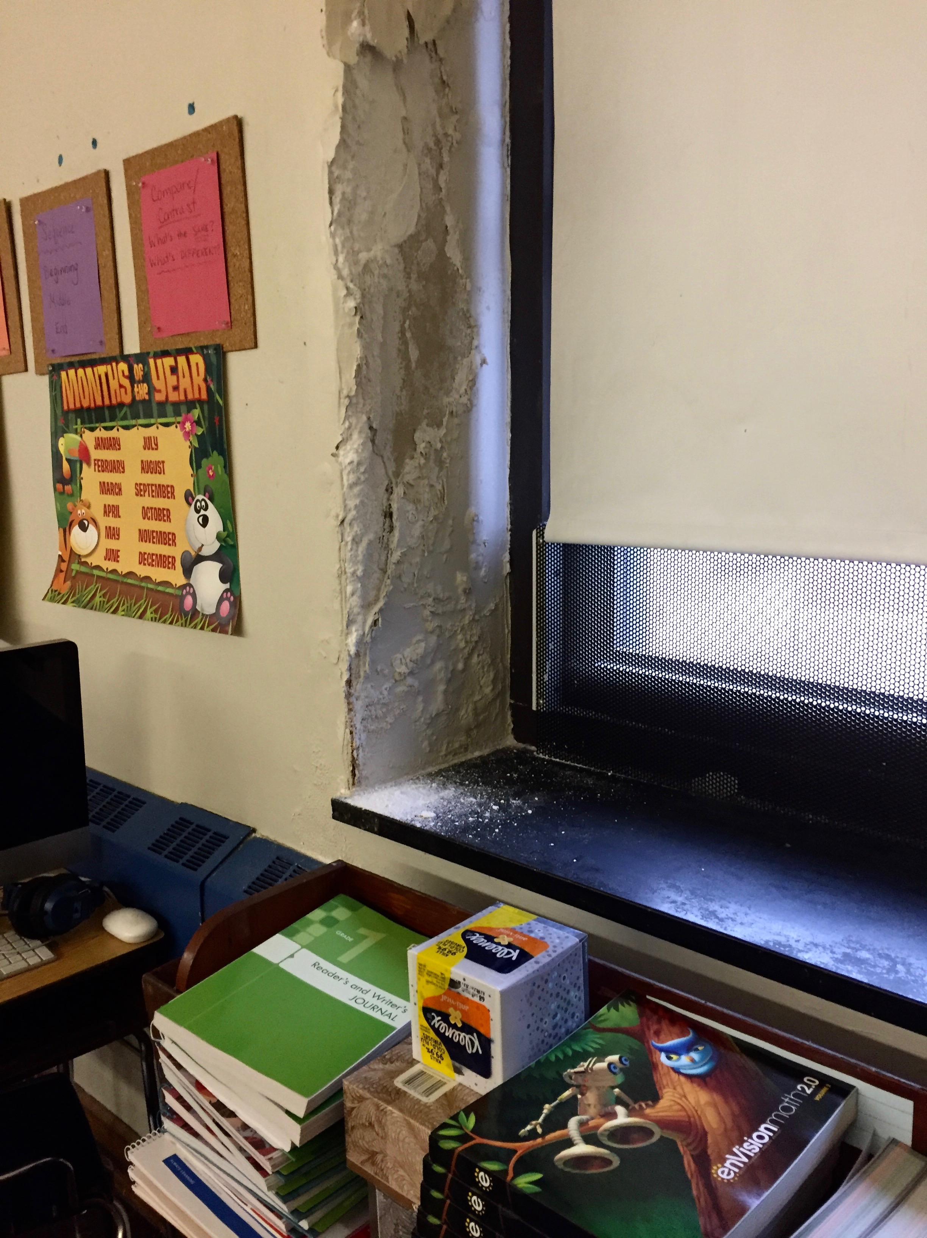

**Photo 1: AS Jenks E.S. – 09.29.2016 – Room 106 – Close up of Wall Damage Around Windows**

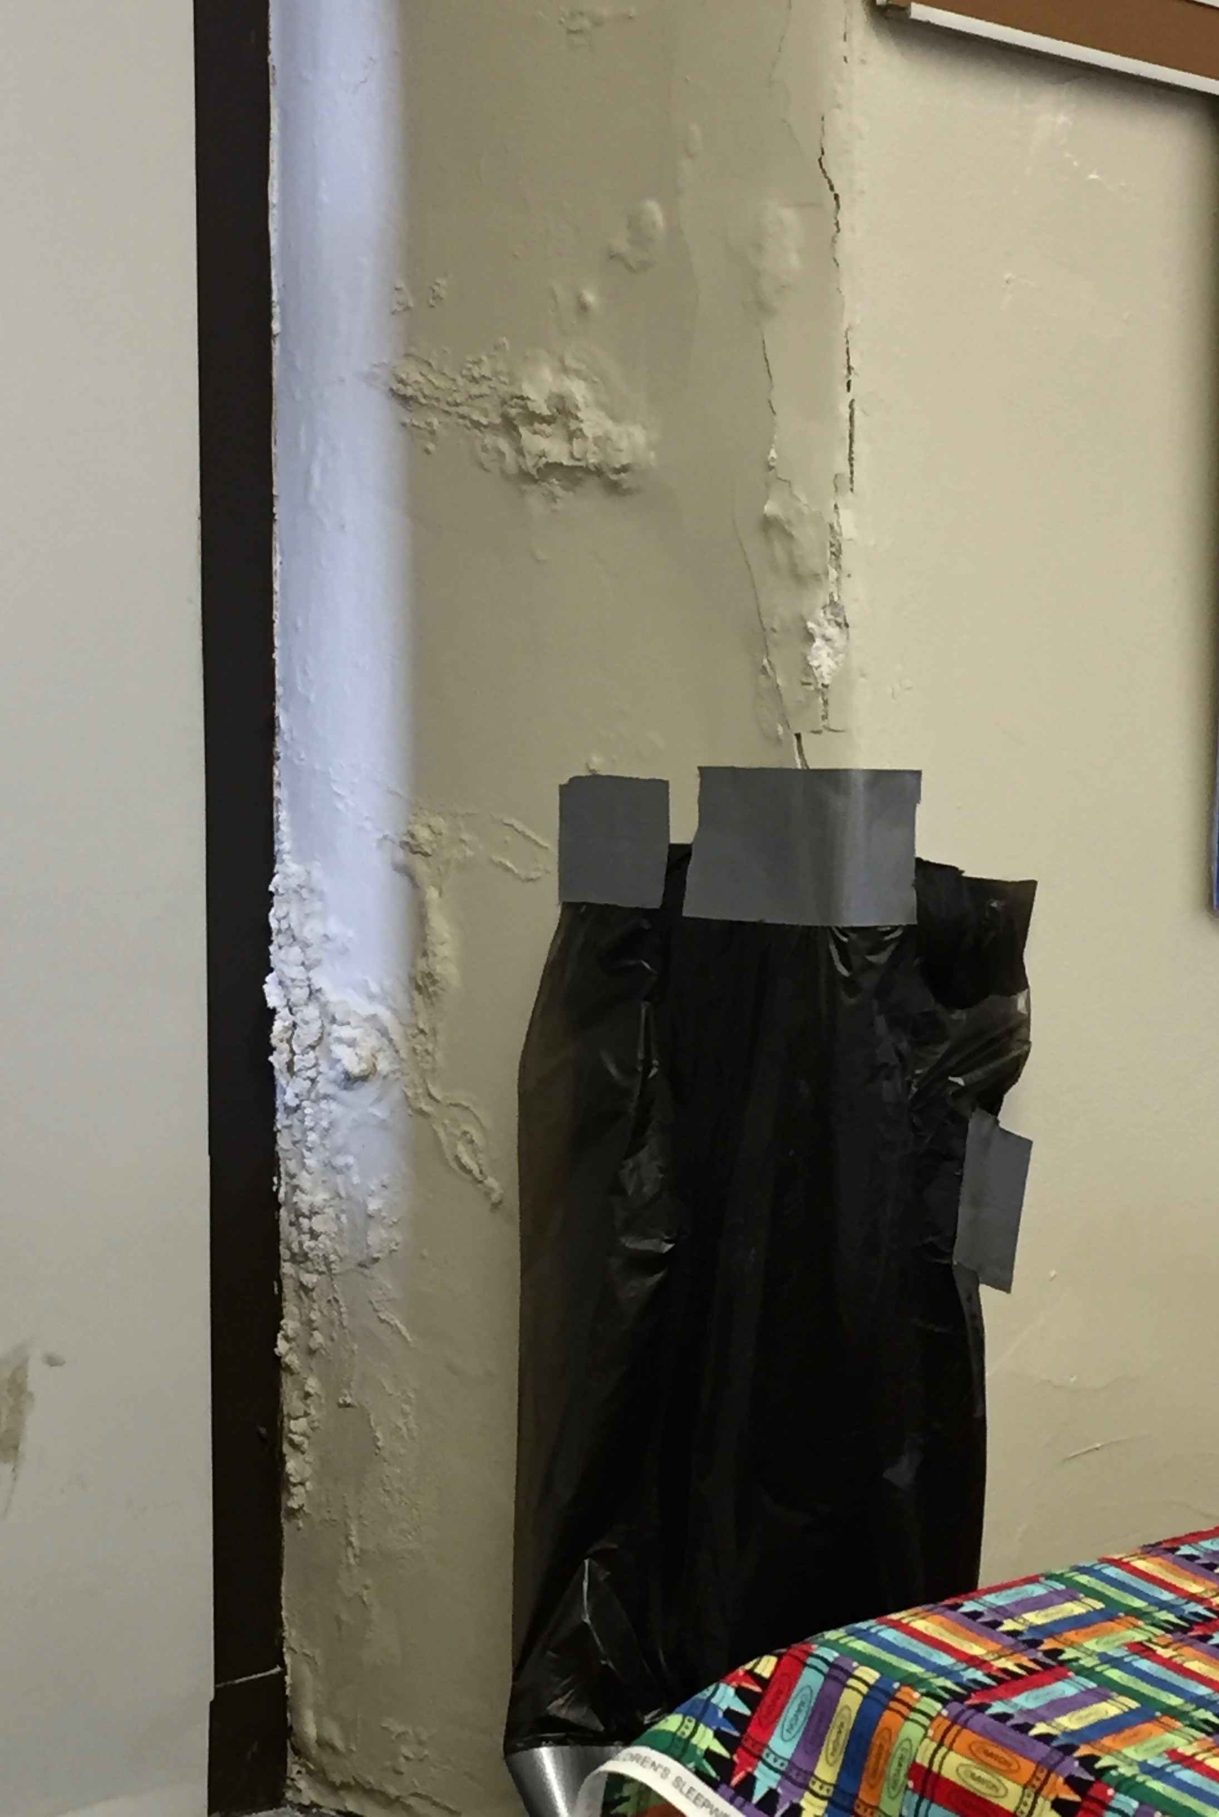

**Photo 2: AS Jenks E.S. – 09.29.2016 – Room 201 – Close up of Wall Damage Around Windows**

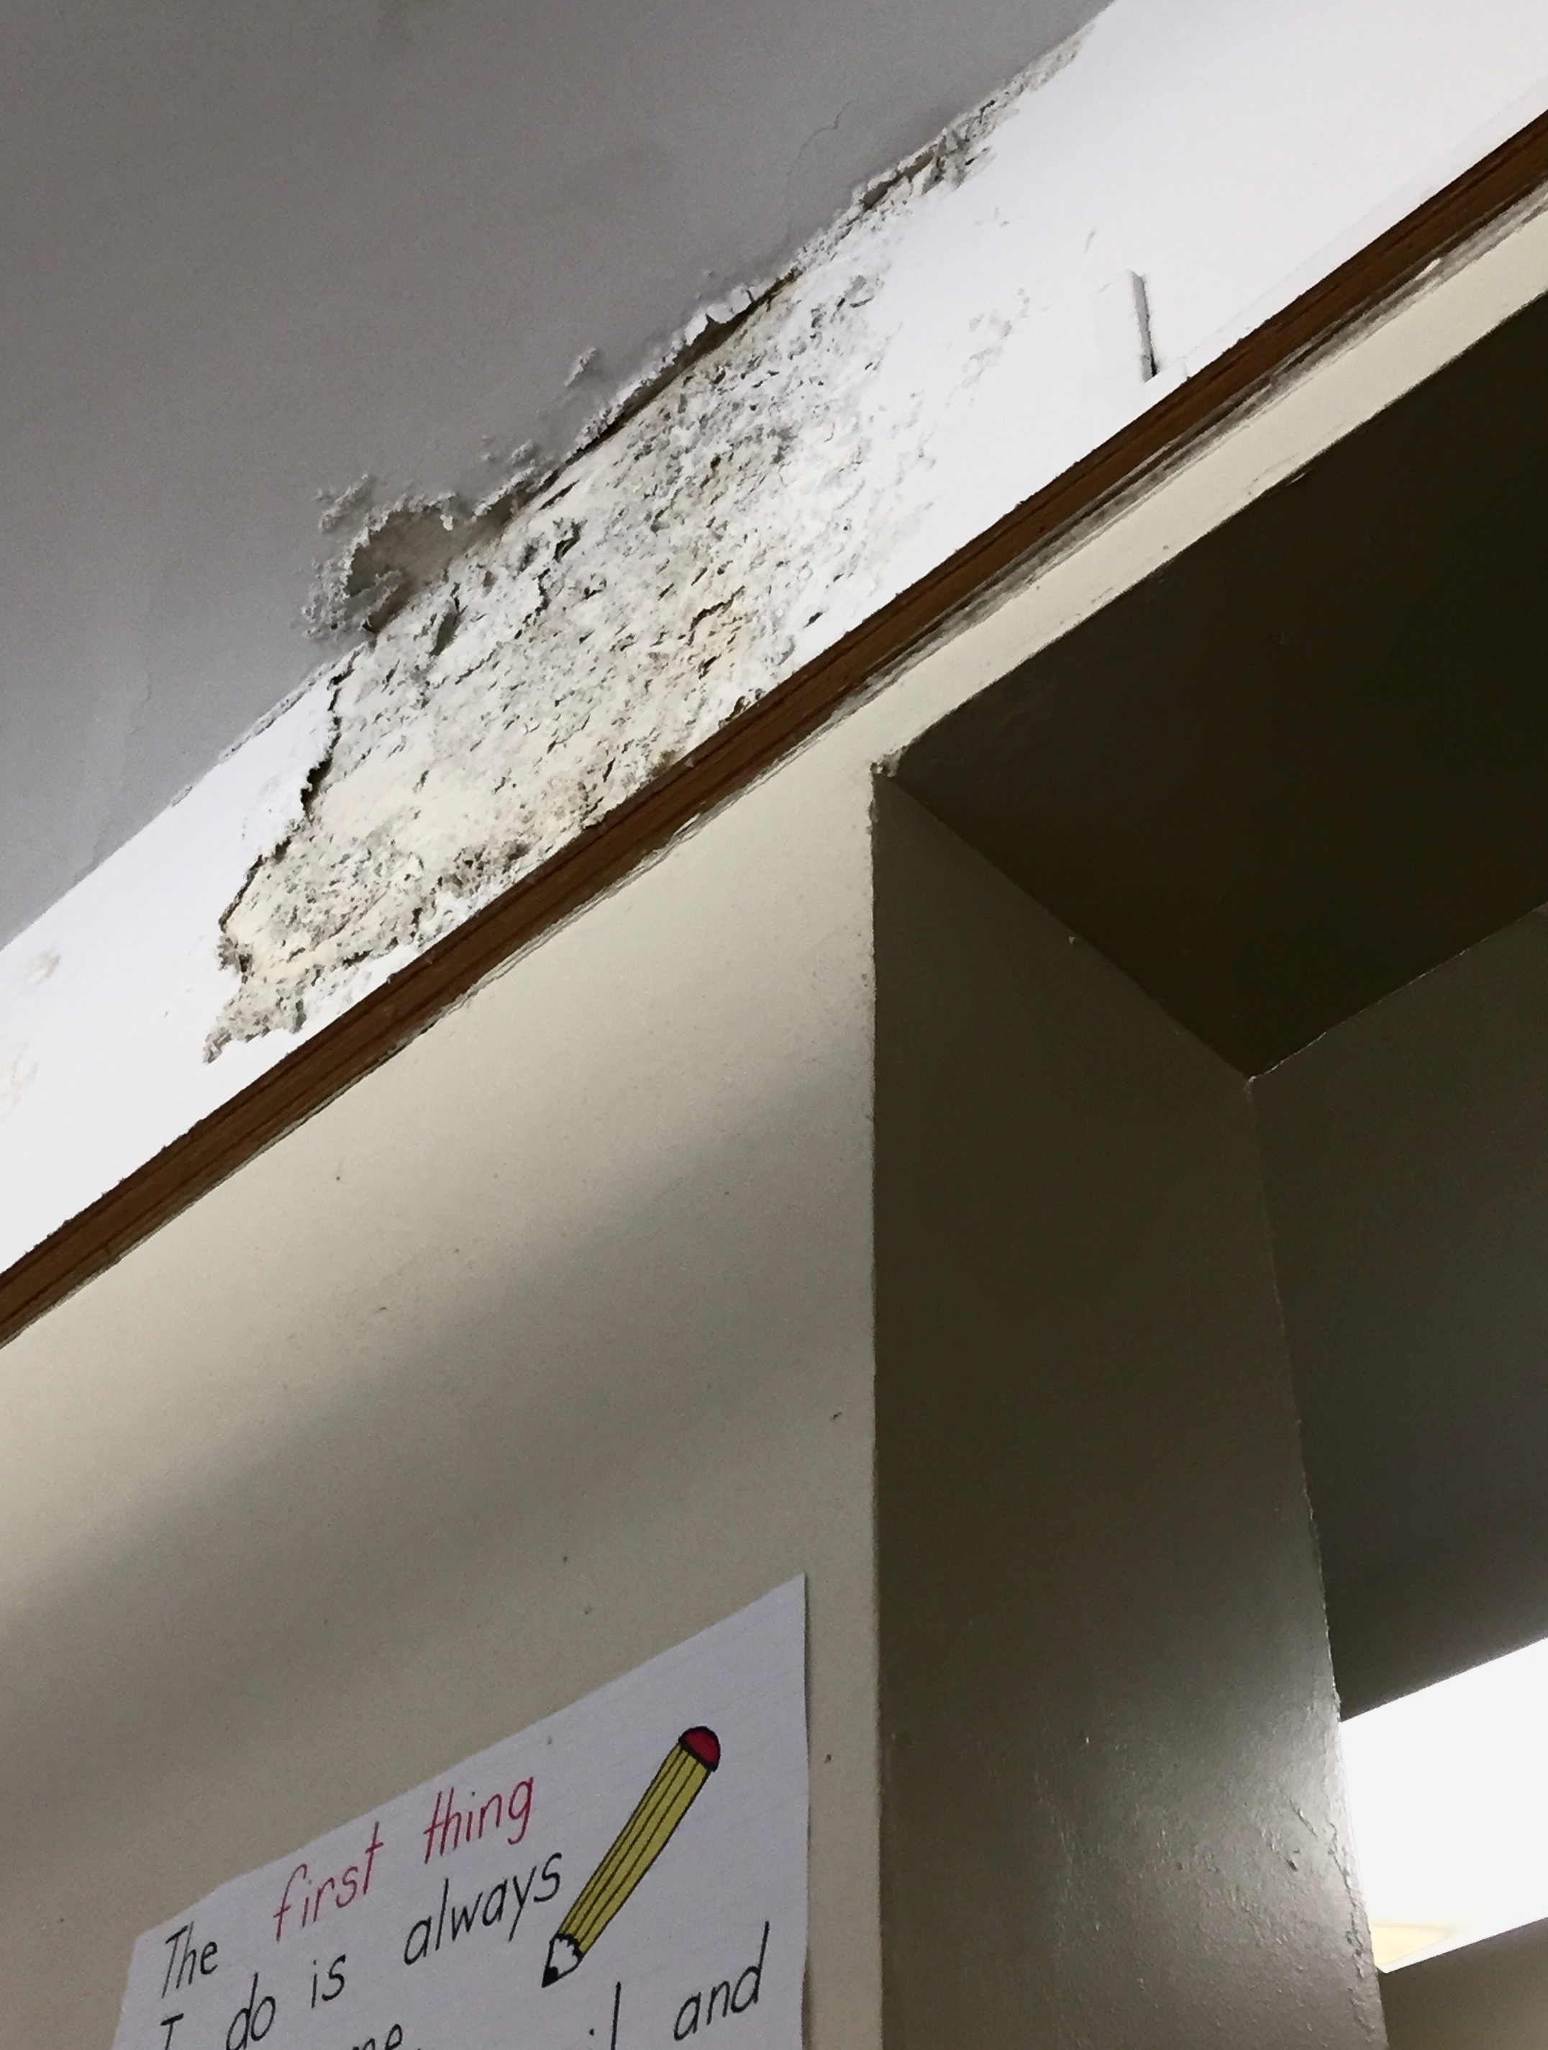

**Photo 3: AS Jenks E.S. – 09.29.2016 – Room 207 – Close up of Wall Damage Around Windows**

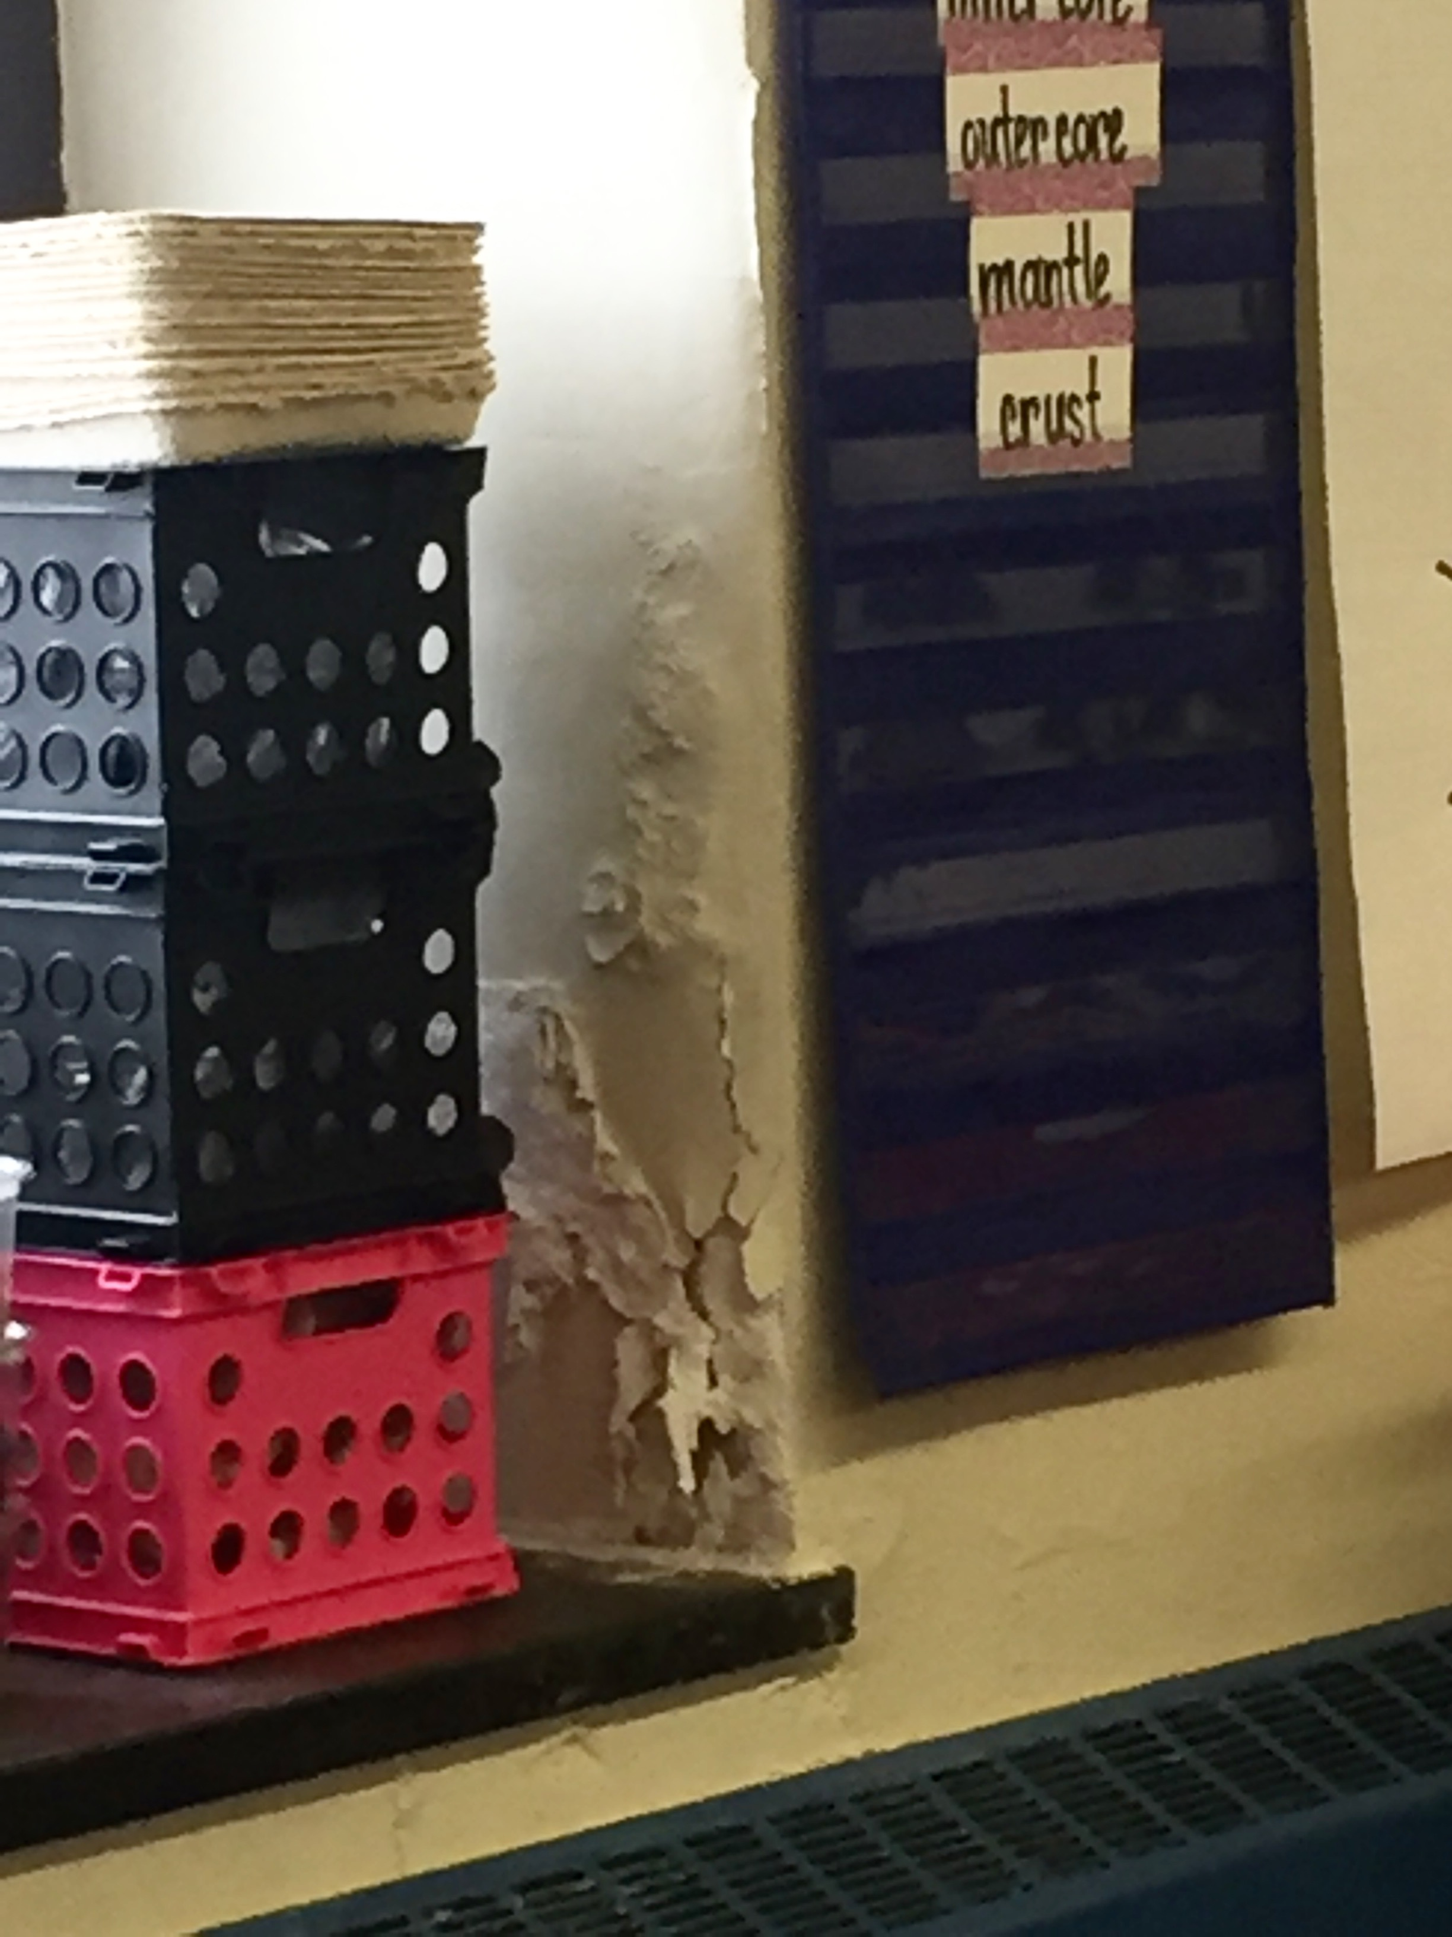

**Photo 4: AS Jenks E.S. – 09.29.2016 – Room 206 – Close up of Wall Damage Around Windows**